**PROJECT METHODOLOGY**

**Introduction**

This chapter will cover the details explanation of methodology that is being used to make this project complete and working well. Many methodology or findings from this field mainly generated into journal for others to take advantages and improve as upcoming studies. The method is use to achieve the objective of the project that will accomplish a perfect result. In order to evaluate this project, the methodology based on System Development Life Cycle (SDLC), generally three major step, which is planning, implementing and analysis.

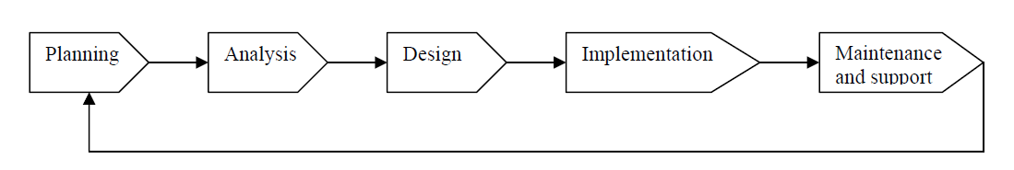

This final year project used three major steps to implement project starting from planning, implementing and testing. All the methods used for finding and analyzing data regarding the project related.

**Planning**

To identify all the information and requirement such as hardware and software, planning must be done in the proper manner. The planning phase have two main elements namely data collection and the requirements of hardware and software

**Data collection**

Data collection is a stage in any area of study. At this stage I planned about the projects resources and requirements, literature studies and schedule to get more information in this study. All the materials are collected from journal, texts book and research papers gathered from libraries and Internet.

Within the data collection period I have found the study about the FM Telephone Transmitter in the Internet and do some research about the project related. Once I got the project manual, I tried to find out the electronic component and other materials and some of equipment to be used.

While planning, I have done the research about the project related, which including with study about the electronic component such as capacitor, resistor, inductance, transistor and diode. The study is not just for the function of the component but the types of small circuit build by each component related.

